**Carl Laurence Ranola SCORE:__________**

**12 ICT CHARLES BABBAGE DATE: ___________**

**QUARTER II**

**ACTIVITY 1**

**INPUT**

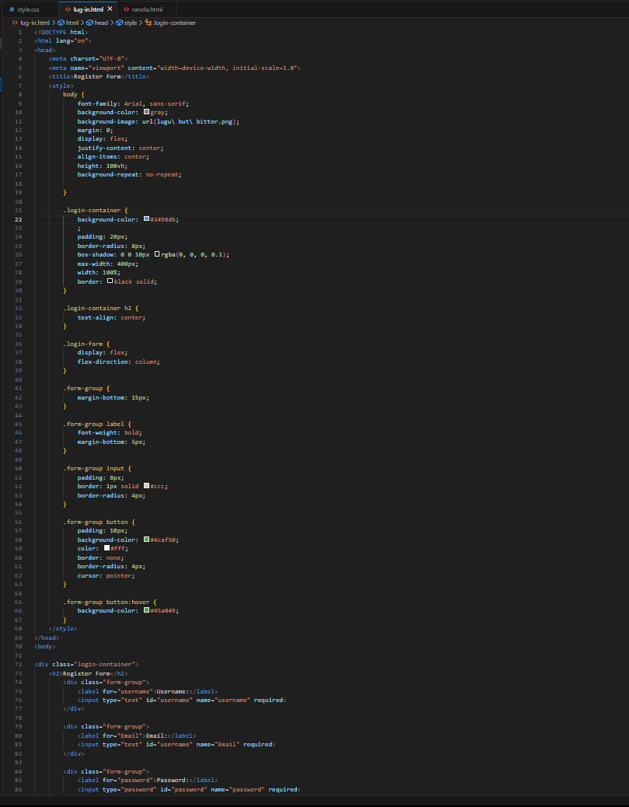

**OUTPUT:**

